Activity 1:

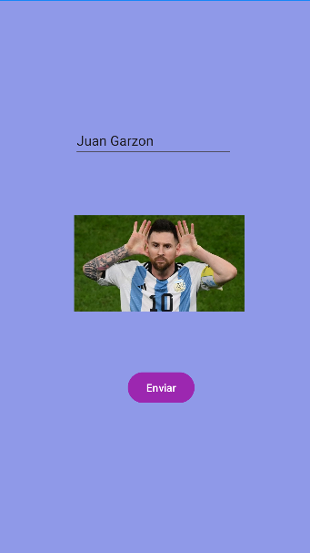

Activity 2:

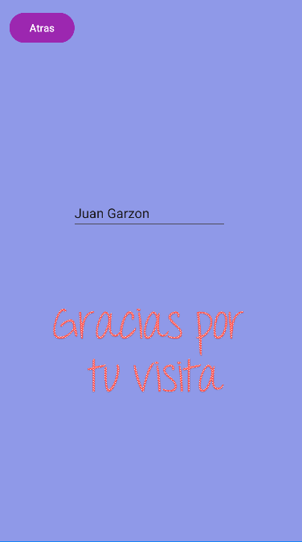

Código:

Actvity 1:

package com.example.myapplication  
  
import android.content.Intent  
import android.os.Bundle  
import androidx.appcompat.app.AppCompatActivity  
  
  
class MainActivity : AppCompatActivity() {  
 override fun onCreate(savedInstanceState: Bundle?) {  
 super.onCreate(savedInstanceState)  
 setContentView(R.layout.*activity_main*)  
  
 *buttonSend*.*button* **{** val name = *editTextText*.*text*.toString()  
 val intent = Intent(this, MainActivity2::class.*java*)  
 intent.putExtra("Juan Garzon", name)  
 startActivity(intent)  
 **}** }  
}

Activity 2:

package com.example.myapplication  
  
import androidx.appcompat.app.AppCompatActivity  
import android.os.Bundle  
import kotlinx.android.synthetic.main.activity2.*  
  
class SecondActivity : AppCompatActivity() {  
 override fun onCreate(savedInstanceState: Bundle?) {  
 super.onCreate(savedInstanceState)  
 setContentView(R.layout.*activity_main2*)  
  
 val name = *intent*.getStringExtra("name")  
 textViewDisplay.text = "Juan Garzon, $name"  
  
 *supportActionBar*?.setDisplayHomeAsUpEnabled(true)  
 }  
  
 override fun onSupportNavigateUp(): Boolean {  
 onBackPressed()  
 return true  
 }  
}

Test: